# **Laboratory Exercise #1**

## ***Background:***

The laboratory workstations in RVR-3017 are equipped with a triple-output power supply shown in Figure 1. The power supplies are in two sections: the 6-V[1] section and the ±25-V section. The 6V section comprises one voltage source. The maximum voltage this source can provide is 6V[2], but its output voltage is adjustable from 0 to 6 volts. It should be noted that this source is “floating”; that is, neither terminal of the source is used for any other purpose and neither terminal is constrained to be at ground potential.

The ±25-V section comprises two voltage sources with a shared “common” terminal (as shown in Figure 1). The voltage sources are named “+25V” and “-25V” but they are independently adjustable to voltages of lesser magnitudes.

The ground terminal on the power supply is simply a connection to the ground wire which is part of the building wiring for AC power distribution. Note that the ground terminal is not connected to any of the voltage sources in the power supply. You cannot obtain a complete circuit by using only the + terminal of a voltage source and the ground terminal. In fact, your circuit may not need to be connected to this ground at all; it probably is connected to the same ground through another path (e.g., the ground side of an oscilloscope input).

Power supplies are used to convert distributed AC power (usually 60Hz, 120VAC) to constant DC voltages. For microelectronics applications, the DC voltages required are on the order of 5-10 volts, and new CMOS technologies operate using DC power supply voltages less than one volt. DC power supplies may have as few as two controls, summarized here:

* VOLTAGE: The voltage control sets the DC output voltage of the supply. The output voltage will remain constant at the value set by the user as long as the current supplied to the load is less than the maximum current setting. This mode of operation is therefore called the "controlled voltage (**CV**)" mode. Most of the time, power supplies are used in the controlled voltage mode. That is, the user sets the output voltage to the desired value then the resulting current depends on the characteristics of the load. For example, the relationship between voltage and current for a resistor is given by Ohm’s law.
* CURRENT: This control sets the maximum current the unit will supply (i.e., a current limit). If the current reaches this limit, the power supply voltage will drop to whatever value is required to keep the current equal to the set limit. This mode of operation is therefore called the "controlled current (**CC**)" mode, meaning that the current limit setting is actually determining the load current. In this case, the voltage across the load is determined by the current and the load characteristics. Usually, the power supply changes to this mode because of an unexpected increase in current demanded by the load, and it is important for the user to see that the voltage is no longer at its set value. Indicators of this mode may also be labeled "current limit".

Our power supplies will display “CC” or “CV” on the front panel depending on the mode.

It is wise to set the current limit to a reasonable value for the work being done (perhaps 150% to 200% of the expected maximum current). This will protect the circuit in the event that a fault occurs that would otherwise cause a high and destructive current to flow.

It should be noted that although the power supply has separate controls for voltage and current, no power supply can independently set the load voltage and load current. The characteristics of the load determine the relationship between its voltage and current.

## ***Experiment***

**Step 1.** Connect a resistor of known value (measure the resistor using the DMM) across the terminals of the 6V power supply. Before applying power, estimate the power dissipation in the resistor for the 6V case and be sure it is below about 1 watt. If it is above that value, check with your instructor and avoid touching the resistor when the power is on and for a while afterwards; it may be quite hot. Apply a voltage between 3 and 4 volts across the resistor. The display should indicate “CV” for controlled-voltage mode. Read the voltage and corresponding current for the 6V supply, using the meter on the supply. If your current reading is not at least two significant figures, check with your instructor. Calculate the value of the resistor from your voltage and current measurements obtained from the power supply meter. (Note: the power supply meter is not intended for high-accuracy measurements, and you will have some experimental error. Check with your instructor to see if you have too much error.)

For five different voltages, measure and record the corresponding current. Enter these data into a spreadsheet program and produce a chart. Save the spreadsheet.

**Step 2.** Enter a current limit into your power supply using the procedure described in the user’s manual. For the current limit, select a value that is approximately the midpoint between the lowest and highest current values recorded in Step 1. Repeat Step 1 for the very same five voltage values used in Step 1. Describe what happens as you exceed the current limit. **Show the results of Step 1 and Step 2 to your instructor.**

**Step 3.** Construct the circuit of Figure 2. Use two different resistor values for 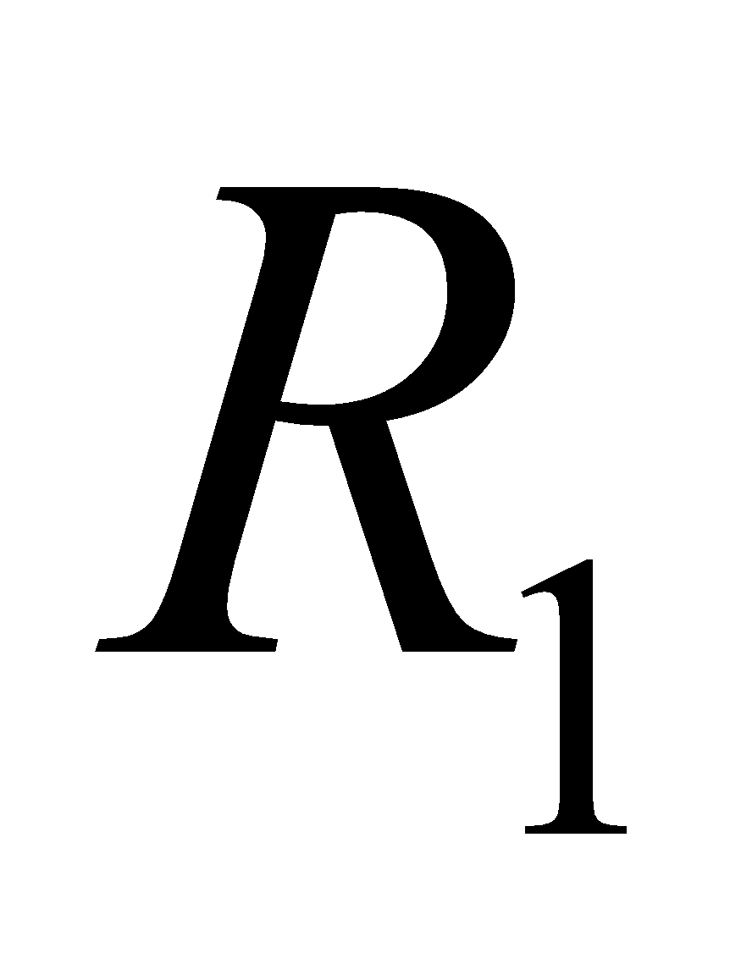 and 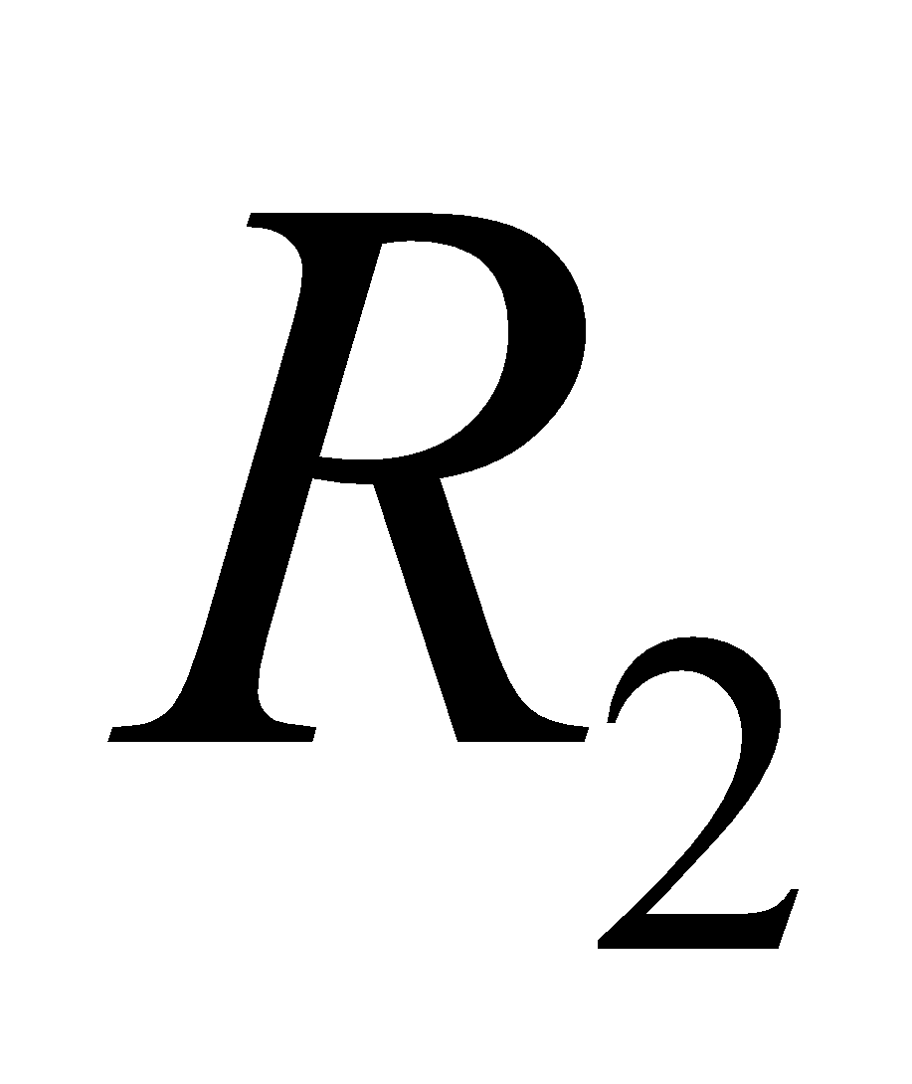, and measure the resistor values before connecting them in the circuit. Set 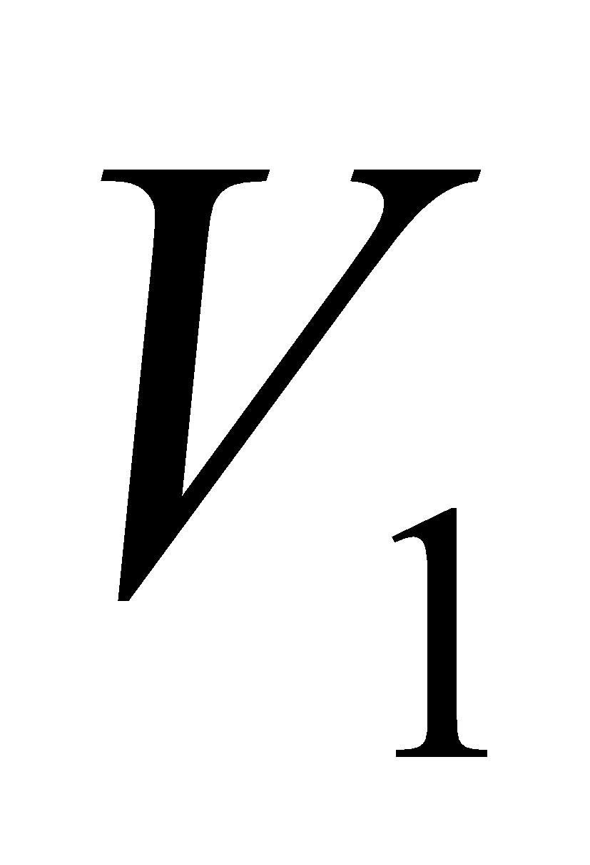 and 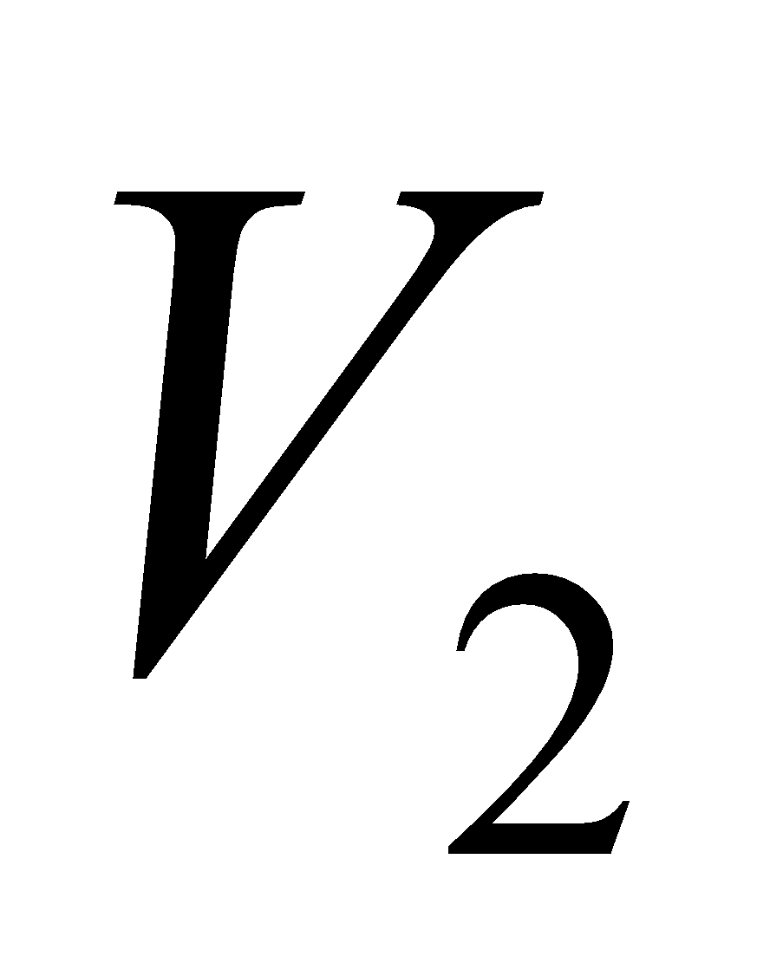 to different values. Note carefully the polarity of the voltage sources. 

**a)** Measure and record the ***independent variables***. The independent variables are , , , and . These are called “independent variables” because their values are independent of the experimental result. The voltages  and  are set by the student, and the resistances  and  are selected by the student. None of the independent variables will change if another of the independent variables is changed. The other measured voltages in the circuit are the ***dependent variables***; that is, they depend on the independent variables.

**b)** Use the DMM as a voltmeter to measure and record the voltages 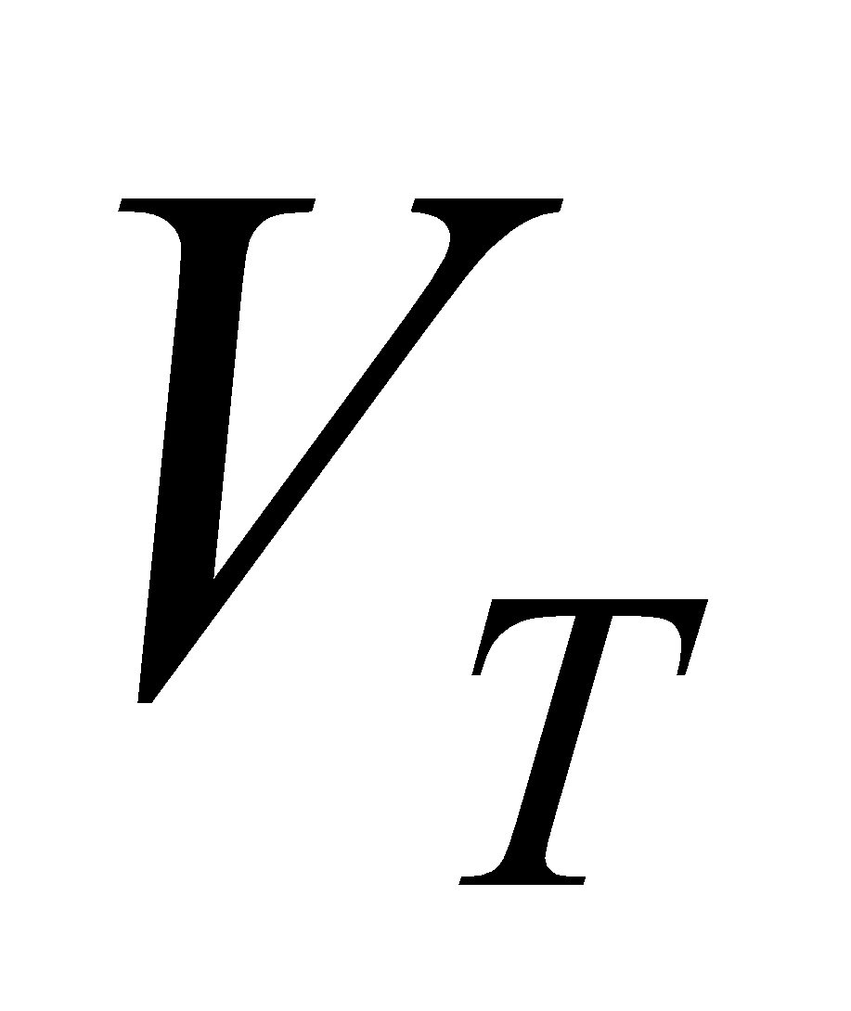, 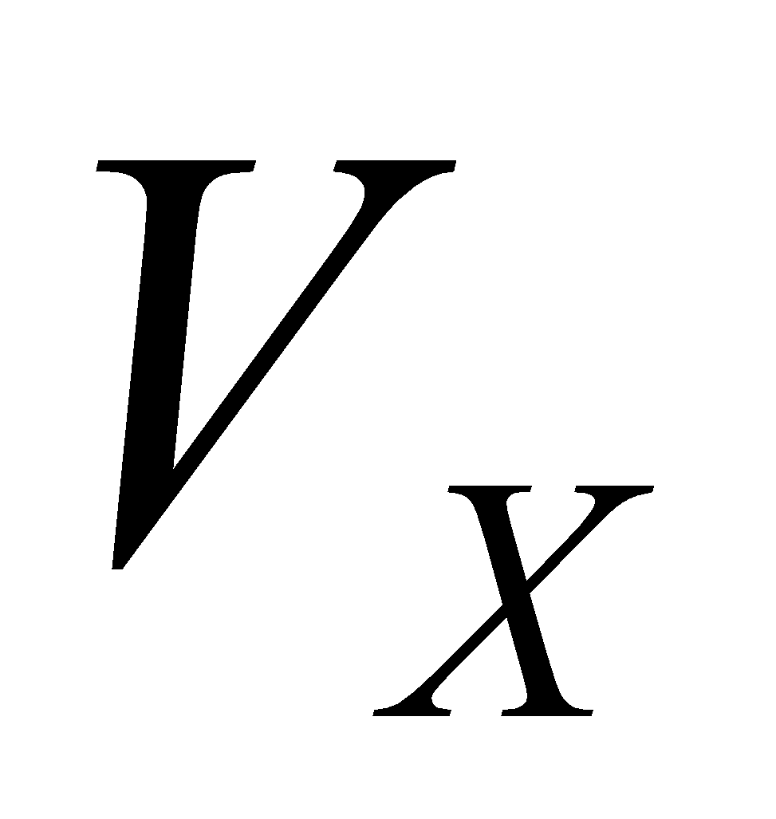, 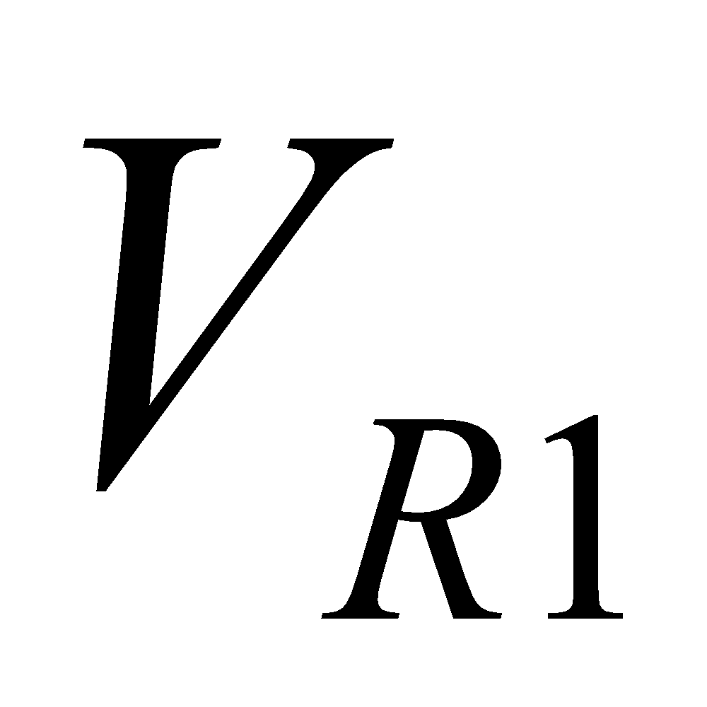, and 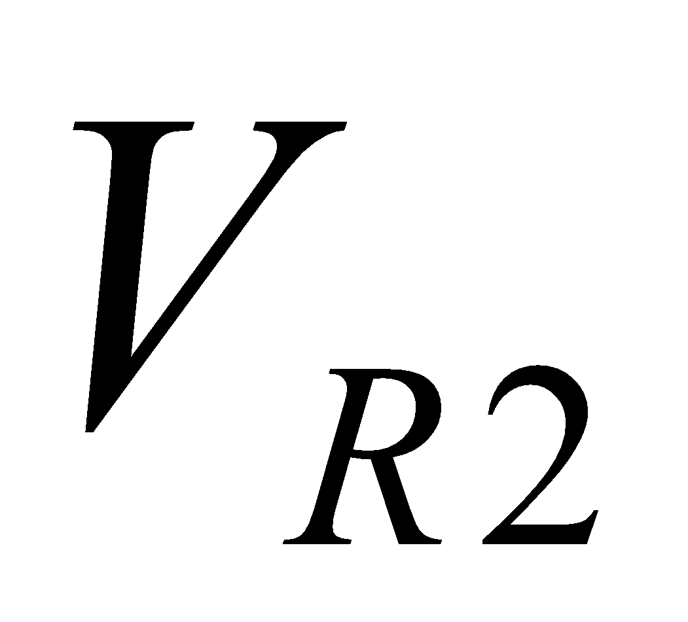 as labeled in Figure 2.

**c)** Calculate values for the dependent variables , , , and  using basic circuit analysis and the measured values of the independent variables ,,  and .

## ***Report:***

Write a report based only on Step 3. Present your Procedure, Analysis, Data, and Conclusions.

* **Procedure:** Make a written record of what you did to obtain the measurements. The procedure should be detailed enough so that another engineer could repeat the experiment, using only your written procedure as a guide.
* **Analysis:** This is an essential section of most experiment reports. In general, this section would be used to provide the theoretical relationship between the independent variables (the “inputs” of the experiment) and the dependent variables (the “outputs” of the experiment). In this experiment, you do not need to show an analysis of the circuit of Figure 2; simply state the equations that will be shown in class.
* **Data:** Present a clear record of the numerical data obtained from measurements of both the independent variables and the dependent variables. Make a table with columns for measured value, calculated value, and percent difference.
* **Conclusions:** State what was learned and/or what physical principles were confirmed by the experiment.

1. The abbreviation “V” stands for “volts” and is capitalized because the units of volts are named after a person.
2. It should be noted that compound adjectives should be hyphenated. Hence the phrase “**6-V** section” uses a hyphen because “6” and “V” ***together and jointly*** modify the word “section.” Later, in the phrase “maximum voltage this source can provide is 6V” there is no hyphen between the “6” and the “V” because they are not acting together to modify **another** word.